**ECE/CS 498 DSU/DSG Spring 2020**

**In-Class Activity 6**

NetID: ____________________________________________________________________________

The purpose of the in-class activity is for you to:

1. Review concepts related to SVM and neural networks
2. Work out steps in backpropagation for optimization of a neural network

# Support Vector Machine

## Linear decision boundary

### Sketch the hyperplane $-2+x_{1}+2x_{2}=0$. Indicate the set of points for which $-2+x_{1}+2x_{2}>0$, as well as the set of points for which $-2+x_{1}+2x_{2}≤0$.

## Non-linear decision boundary

### Sketch the curve ${\left(1+x_{1}\right)}^{2}+{\left(2-x_{2}\right)}^{2}=4$.

### On your sketch, indicate the region for which ${\left(1+x_{1}\right)}^{2}+{\left(2-x_{2}\right)}^{2}>4$, as well as the region for which ${\left(1+x_{1}\right)}^{2}+{\left(2-x_{2}\right)}^{2}≤4$.

### Suppose that a classifier assigns an observation $\left(x_{1}, x_{2}\right)$ to the blue class if ${\left(1+x_{1}\right)}^{2}+{\left(2-x_{2}\right)}^{2}>4$, and to the red class otherwise. To what class is the observation $\left(0, 0\right)$ classified? $\left(-1, 1\right)$?

### The decision boundary equation in c) is not linear in terms of an input $x=$ ($x_{1}$, $x_{2}$) since it has $x_{1}^{2}$ and $x_{2}^{2}$ terms. However, suppose that we instead consider $x=$ ($x_{1}$, $x_{1}^{2}$, $x_{2}$, $x_{2}^{2}$). This might be the case after applying a kernel transformation to the dataset. Is the decision boundary equation linear then? What might be a reason for applying this kernel transformation?

## Hard margin SVM

Suppose we are learning a hard margin SVM with two real-valued features $x_{1}, x_{2}$ and binary label $y∈\left\{-1,+1\right\}$ (represented by △ and ○, respectively). The training data is pictured in the figure below. Our linear classifier takes the form .



H1

H2

### According to the maximum margin principle, identify the support vectors, and sketch the decision boundary of the trained SVM.

### Suppose hyperplane $H_{1}$ takes the form $w∙x+b=1$, write down the equations for $H_{2}$.

### The constraints for linear hard margin SVM can be written as $y_{i}\left(w∙x_{i}+b\right)≥1, ∀i∈\left\{1, …, N\right\}$. Explain why.

### What condition do the data points have to satisfy such that a feasible $w$ exists?

### Calculate the distance between $H_{1}$ and $H_{2}$.

### Based on your answer to the above questions, write down the optimization problem whose solution is hard margin SVM.

### For the following data points $x_{1}=\left(1,2,3\right), x_{2}=\left(4,1,2\right),x_{3}=\left(-1,2,-1\right)$ corresponding to class $y_{1}=+1, y_{2}=+1, y_{3}=-1$, one of the following $w$, $b$ gives the correct SVM decision boundary ($w∙x+b=0$). Which one is it? Show your work.

$w={\left[0.3, 0, 0.4\right]}^{'}, b=-0.4$

$w={\left[0.2, 0, 0.4\right]}^{'}, b=-0.4$

$w={\left[0.1, 0, 0.4\right]}^{'}, b=-0.4$

$w={\left[0.4, 0, 0.2\right]}^{'}, b=-0.4$

## Soft margin SVM

Recall the program for solving the soft margin SVM:

$\min_{w, ξ_{I}≥0}{\frac{1}{2}{\left|\left|w\right|\right|}^{2}+C\sum_{i}^{N}{ξ_{i}}}$ $s.t. 1-ξ_{i}≤y_{i}\left(w^{T}x_{i}+b\right) ∀i∈\left\{1, …, N\right\}$

We have plotted the SVM solutions for a training dataset in Figure (a) and (b) corresponding to two values of :

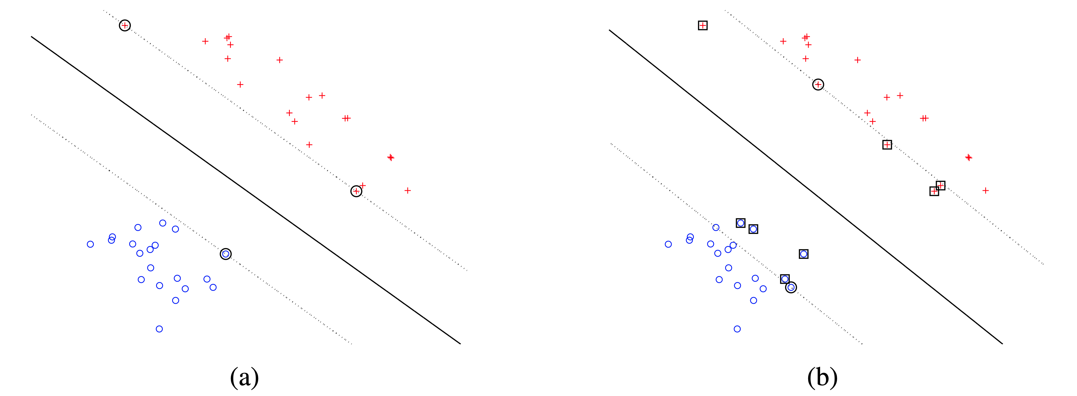

### Indicate non-zero $ξ_{i}$ s on both plots (a) and (b).

### Which figure corresponds to a larger value of $C$? Explain why.

The unconstrained form of the above optimization problem is given as:

$$\min_{w, b}{\frac{1}{2}{\left|\left|w\right|\right|}^{2}+C\sum_{i}^{N}{\max\left\{0, 1-y_{i}\left(w^{T}x_{i}+b\right)\right\}}}$$

### Draw the function $g\left(z\right)=\max\left\{0, z\right\}$ for scalar variable z. What is the derivative $\frac{dg(z)}{dz}$? Draw the derivative.

### Compute the gradient of this unconstrained program w.r.t $w$. [Hint: Think of $z$ in part (c) as $1-y_{i}(w^{T}x_{i}+b)$, you can express max in terms of an indicator function]

### Suppose you are training your SVM using gradient descent and the gradient derived in (d), the original gradient is $w={\left[2,2\right]}^{'}, b=-1$. The first iteration we trained on data point $x_{1}=\left(1,1\right),y_{1}=1$; the second iteration we trained on data point $x_{2}=\left(-1,-1\right), y_{2}=-1$, $λ=1$, assuming both C and learning-rate to be 1 calculate the gradient after these two iterations.

# Neural Networks

## Partial derivatives

Consider the network shown in the figure below. All the hidden units use the ReLU- $h_{i}\left(z_{i}\right)=\max\left\{z_{i}, 0\right\}$. We are trying to minimize a cost function $C$ which depends only on the activation of the output unit $y$. The unit $h_{1}$ (marked with a *) receives an input of $z_{i}=-1$ on a training iteration, so its output is $0$. Based only on this information, which of the following weight derivatives are guaranteed to be $0$ for this training case? Write YES or NO for each. Justify your answers informally. (Hint: don’t work through the backprop computations. Instead think about what the partial derivatives really mean.)

$\frac{∂C}{∂w_{1}}$

$\frac{∂C}{∂w_{2}}$

$\frac{∂C}{∂w_{3}}$

# 

## Backpropagation

## The neural network considered in this question has three input neurons, one hidden layer with two neurons, and one output layer with two neurons. $b_{1}$ and $b_{2}$ are bias terms.



### Suppose $zh_{1}={w_{1}x}_{1}+w_{3}x_{2}+w_{5}x_{3}+b_{1}$, $h_{1}=sigmoid\left({zh}_{1}\right)$, and similar relationships hold for the other neurons in the hidden/output layer. Assume the current parameters of the networks $w_{1},w_{2},w_{3},w_{4},w_{5},w_{6},w_{7},w_{8},w_{9},w_{10}=0.1, 0.2, 0.3, 0.4, 0.5, 0.6, 0.7, 0.8, 0.9, 0.1, b_{1}, b_{2}=0.5, 0.5$. Given input $x_{1}, x_{2},x_{3}=1, 4, 5$, use forward propagation to find out the value of $h_{1},o_{1}.$ You can think of writing a Python program.

### Let $t_{1}, t_{2}$ represent the true labels. Define the sum of squared loss $E= \frac{1}{2}({\left(o_{1}-t_{1}\right)}^{2}+{\left(o_{2}-t_{2}\right)}^{2})$. **Write down the partial derivatives $\frac{∂E}{∂w_{7}}, \frac{∂E}{∂b_{2}},\frac{∂E}{∂w_{1}}$ according to the chain rule**. Example for $\frac{∂E}{∂w_{10}}, \frac{∂E}{∂w_{2}}$ is given below. $$\frac{∂E}{∂w_{10}}= \frac{∂E}{∂o_{2}}\frac{∂o_{2}}{∂{zo}_{2}}\frac{∂zo_{2}}{∂w_{10}}$$

$$\frac{∂E}{∂w_{2}}= \frac{∂E}{∂o_{2}}\frac{∂o_{2}}{∂{zo}_{2}}\frac{∂zo_{2}}{∂h_{2}}\frac{∂h_{2}}{∂{zh}_{2}}\frac{∂zh_{2}}{∂w_{2}}+\frac{∂E}{∂o_{1}}\frac{∂o_{1}}{∂{zo}_{1}}\frac{∂zo_{1}}{∂h_{2}}\frac{∂h_{2}}{∂{zh}_{2}}\frac{∂zh_{2}}{∂w_{2}}$$ For $\frac{∂E}{∂w_{2}}$, look at the two paths which lead from $w_{2}$ to $E$. Backpropagation includes both the paths in the calculation.

### Suppose $t_{1},t_{2}=0.1, 0.05$, learning rate $α=0.01$. Calculate the updated $w_{7}, b_{2}, w_{1}$ after one iteration of backpropagation. Use $h_{2}=$ 1, $o_{2}=0.8.$

## Neural Network Playground (for you to explore)

<https://developers.google.com/machine-learning/crash-course/introduction-to-neural-networks/playground-exercises>